**Functional Document**

|  |  |
| --- | --- |
| **Application** | NGERP - Centra |
| **Service Bundle** | Inventory Management |
| **Service Request** | Production |

**Description :**

Production screen is used to create BOM(Bill Of materials) . The BOM product consist of one or more child product. In production child products are grouped together to produce a single product.

**Workflow Process :**

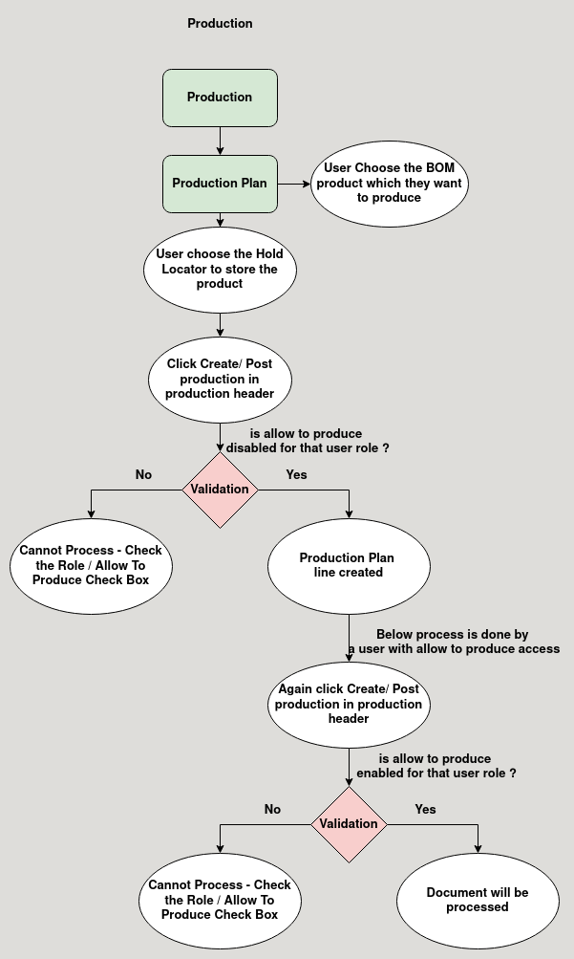

**Business Rules :**

* Production can be done only in region.
* Production can be done only in hold warehouse.
* User should enter the name for the production in production header.
* After adding the name in header the user should create the production plan.
* The production plan consist of the BOM product which they want to produce and quantity of the main product and the locator in which the BOM product will be stored after production
* The BOM product should have atleat one child product to start production.
* The user should not have allow to produce box checked in the role screen to add the production line.
* Click the create/post production button in the production header to create production line automatically.
* After the lines are created in production line , the records created box will be checked in the production header.
* Now the user with the role allow to produce box is checked can now begin the production by again clicking create/post production button in the production header.
* Now the child product of the BOM product will be reduced and the BOM product quantity will be increased in the locator.